INTERNATIONAL CENTER FOR ACADEMIC
AND PROFESSIONAL ENGLISH (ICAPE)

Academic Literacies Workshops - Summer 2023
The International Center for Academic and Professional English offers workshops on communication skills and cultural awareness for students, faculty, and staff. Workshops are free for members of the Lehigh community and $25 for all others.
To register for a workshop, visit: global.lehigh.edu/icape/workshops

Time Management
Kayla Landers and Mary Newbegin
-Thursday, July 6 at 9:45 - 10:45 am EDT via Zoom (Link here)

*So much reading and homework and so little time! In this workshop, learn practical time management skills that you can apply right away, like using Google Calendar to schedule appointments and classes and tips for prioritizing assignments.

LU Advising
Jessica Harbaum and Emily Ford (LU Advise collaboration)
-Tuesday, July 11 at 9:00 - 10:00 am EDT via Zoom (Link here)

*Your academic advisor is not only a resource for class registration, but can help you find opportunities and become a successful student. In collaboration with Emily Ford, the Director of Coordinated Advising at Lehigh University, this workshop will help you learn about the importance and the role of academic advising and support resources in fostering student success as a first-year student and beyond. Get the information that can help you succeed and get the most out of the advising system!

The "Write" Solution: Using Technology to Improve Communication and Writing Skills
Teresa Cusumano and Chris Harvey
Thursday, July 13th at 9:45 - 10:45 am EDT via Zoom (Link here)

*There are many benefits to using technology for writing or preparing presentations, including increased access to resources and ways in which students can gain feedback and improve their spoken and written communication. Technology makes it easy to collaborate, edit, engage with ideas and content in multiple modalities, and practice oral fluency as students record, listen, and edit their work. This workshop will focus on ways that Lehigh supported technologies have made it easier than ever for students to improve their writing skills and engage with course content. Discover Lehigh resources, like experiential learning through virtual reality, to digital recording studios or utilizing grammar checkers and plagiarism detectors; there are plenty of ways for tech-savvy students to get ahead.

College Reading Skills
Mike O’Neill and Jessica Harbaum
-Tuesday, July 18th at 3:00 - 4:00 pm EDT via Zoom (Link here)

*Develop a systematic approach to reading assignments and learn to read more efficiently. This workshop will provide reading strategies that can be adapted to students’ unique learning styles and needs. Discover how to improve comprehension and save time. Plan to be a successful reader—equipped with reading survival skills!

Grow Where You're Planted - Connecting and Engaging on an American Campus
Teresa Cusumano and Michael O’Neill
-Aug 2nd at 9:45 - 10:45 am EDT via Zoom (Link here)

*This workshop will provide information on ways to get involved on campus, while also sharing personal experiences of how getting connected has helped students to be successful both academically and socially here at Lehigh. Learn how to use mistakes as learning opportunities, go beyond your comfort zone, and embrace challenges as educational opportunities.

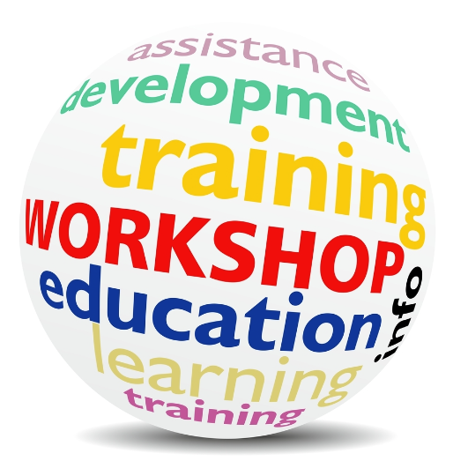

INTERNATIONAL CENTER FOR ACADEMIC
AND PROFESSIONAL ENGLISH (ICAPE)

Graduate Series Workshops - Summer 2023
The International Center for Academic and Professional English offers workshops on communication skills and cultural awareness for students, faculty, and staff. Workshops are free for members of the Lehigh community and $25 for all others.
To register for a workshop, visit: global.lehigh.edu/icape/workshops

Maximizing Vocal Impact for the Professional Interview
Mary Newbegin and Mark Ouellette
-June 8th at 1:30-3:00 p.m. EDT in MG 110 and Zoom (Link here) Hybrid

*When interviewing for a job, how can you greet your interviewer confidently? How should you address that person? Mr.? Mrs.? John? Mary? How do you ask and answer questions clearly and appropriately? How do you use language to balance confidence in yourself with your desire to make a good impression? What if you don’t know how to answer or don’t understand a question? These concerns all address the unwritten cultural and linguistic rules for the professional interview in the US. And understanding some of them will help you have a positive impact on the person interviewing you. In this workshop, you will be introduced to and will practice some key conversational strategies related to grammar, vocabulary, and vocal quality that will maximize your chances for professional success.

Introduction to the American Classroom for TAs
Kayla Landers and Mark Ouellette
-July 19 2023 at 9:00-10:00 am EDT in MG 110 and Zoom (Link here) Hybrid

*TAs who step in an American classroom for the first time may experience some culture shock. In this interactive session TAs will develop an understanding of the American University classroom and an awareness of the social rules by which U.S. students and their teachers operate in order to help prepare themselves to be successful as TAs. This workshop is for graduate students who have been offered a teaching assistantship as well as for those graduate students who just might be interested in learning about being a TA at Lehigh.

Introduction to the Structure of Academic Papers
Ashley Murphy & Yvonne Lee
-July 21, 2023 at 12:00-1:00 EDT pm via Zoom (Link here)
*This workshop is an introduction to the structure of academic papers, including Introductions/Lit Reviews, Methods sections, Results section, and also Problem-Solution structures.

Academic Writing: Grammar and Genre Awareness
Mary Newbegin & Kayla Landers
-July 26, 2023 at 9:00 - 10:00 am EDT in MG 110 and Zoom (Link here) Hybrid

*This workshop focuses on academic writing, addressing stylistic and lexical choices in writing. We’ll review basic grammatical structures, discuss how genre awareness can help graduate writers, and share strategies for revising your writing skills.

The Language of Self-Advocacy
Jessica Harbaum & Patricia Beavan
-August 2, 2023 at 3:30-4:30 pm EDT in MG 110 and Zoom (Link here) Hybrid

*Language is a powerful tool for advocating for yourself. This workshop identifies critical communication skills for basic self-advocacy. Topics will include learning how to speak up for yourself, using concise language, and how to be assertive without being aggressive. The language you choose can be the difference between being heard and being ignored.

Email Correspondence for Academic & Professional Purposes
Mike O’Neill
-Aug 10 at 6:00-7:00 pm EDT via Zoom (Link here)

*Learn the hidden cultural and linguistic rules for writing emails in American academic contexts. Topics include how to write emails to explain an absence to a professor, polite requests to colleagues, and formal complaint emails. Additional topics will include the expectations of email subject lines, greetings, responding, closing, and how much information is necessary to include.

